Information Sheet
County Waterford Creative Ireland
Open Call

The Creative Ireland Programme is the Government’s five-year initiative which places creativity at the centre of public policy. It is a culture-based programme designed to promote individual, community and national wellbeing. It’s vision is:

“That every person living in Ireland will have the opportunity
to fully realise his or her creative potential”

Under the Creative Ireland Programme applications are now being sought for projects and initiatives which will take place in 2018. The maximum grant available to an individual project in this round of funding is €5,000. 75% of the approved project cost will be supported by the County Waterford Creative Ireland Programme with 25% being met by the successful applicants.
Projects and initiatives already supported through any other funding stream from Waterford City and County Council will not be eligible to apply.

We invite you to submit an Application under one of the following funding categories:
 | From | To
Category A Projects | €500 | €1,500
Category B Projects | €1,500 | €3,000
Category C Projects | €3,000 | €5,000

Applications are open to community and voluntary groups, organisations, venues, artists, writers, performers, archaeologists, historians, archivists, schools, colleges and individuals who have something to contribute to creativity and culture within Waterford County. The objective is to relate your project to one or more of the key themes within the County Waterford Culture and Creativity Strategy 2018-2022. The themes are:
- Collaboration
- Communication
- Community
- Participation
- Inclusivity
- Empowerment
We now invite you to see yourselves as co-creators of your own cultural and creative experiences and to mobilise communities of interest.
The aim of this Open Call is to encourage new, ambitious and meaningful collaborations between people and communities and artists/archaeologists/historians/archivists and everyone else involved in the culture and creative sectors within County Waterford
The process
We ask that you complete the attached Application Form. Deadline for submissions is 17:00pm on the 22nd June 2018.
Successful applicants will be notified by 6th July 2018.
Criteria for Assessment
Please note your Application will be assessed under the following criteria:
- Evidence of how this planned project links to a key theme of
The County Waterford - Culture and Creativity Strategy. 30 marks.
- Quality, ambition and evidence of collaboration within
the planned project. 20 marks.
- Outline of who the ‘audience is’ and who will participate. 10 marks.
- Outline of the sustainability and legacy of the project 15 marks
- Capacity/ability and evidence of the applicant to
undertake and realise the project. 10 marks
- Quality and feasibility of the proposed budget submitted. 15 marks
(Note if artists / creative professionals are engaged in the project
evidence must be shown in the budget of the proposed fees).
Please Note an External Panel will be appointed to assess all applications.
If you require further information you can contact creativewaterford@waterfordcouncil.ie

County Waterford – Culture and Creativity Strategy 2018-2022 http://www.waterfordcouncil.ie/departments/culture-heritage/creativeireland.htm
The vision for County Waterford is to create a cultural and
creative ecosystem in Waterford which builds on existing
core strengths, increases cultural competency across the
county to develop and deliver programmes reflective of
community needs, and provides opportunities for access,
participation and engagement in culture and creativity for
all citizens
Local Authorities under the National Creative Ireland Programme have been tasked with implementing Pillar 2 “enabling creativity in every community". We ask you to directly link your idea/proposal/initiative to one (or more) of the six identified key themes in the County Waterford Culture and Creativity 2018-2022, which are outlined below.
Theme 1: Collaboration
Objective: Play a leadership role, with partners, to support a collaborative environment that provides opportunities for shared resourcing to promote culture and creativity.
Theme 2: Communication
Objective: Develops awareness of culture and creativity. Has the potential to reach and engage the target audience.

Theme 3: Community
Objective: Supports culture and creativity across all communities, such as artistic and cultural players, Irish language communities, children, young people and new communities. Provides evidence of community development in the areas of culture and creativity.

Theme 4: Participation
Objective: Provides greater opportunities for participation in cultural activities, either locally or at county level.

Theme 5: Inclusivity
Objective: Demonstrates the value of inclusivity and has inclusion as a key element in the aims of the project.
Theme 6: Empowerment
Objective: Seeks to empower local communities to enhance their way of life through cultural expression and participation in cultural activities.
Some examples of potential projects could include, but are not limited to, the following:
- Projects that enhance the sustainability of those who work in the culture and creativity sectors.
- Projects that encourage people to explore their own creativity, particularly young people.
- Projects that explore culture and heritage in creative and innovative ways.
- One-off projects or events in performing or visual arts, literature, culture or heritage.
- Workshops, talks or lectures in performing or visual arts, literature, culture or heritage.
- Commissions for new work.

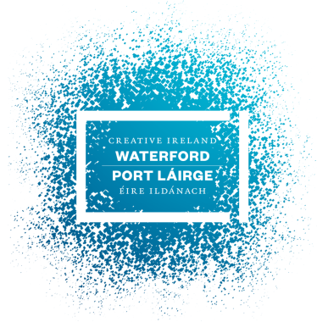 | 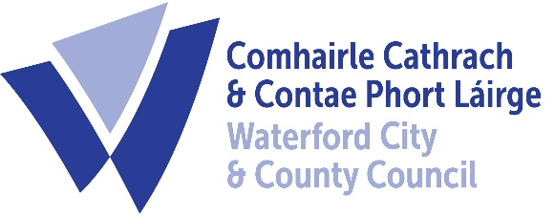

County Waterford – Creative Ireland
Application Form

Where possible please print in clear written text or type.

Name:

Contact details (email and telephone):

Name of the lead individual/organisation/community/voluntary group and location:

Brief description of who you are and list those you intend on collaborating
with (100 words max):

Outline of your proposed idea/project/initiative (Please attach a maximum of 2x A4 sheets)
This should be brief and include:
- An outline of your proposed idea/project/initiative.
- Tell us how your proposed idea links to a key theme or themes defined in The County Waterford – Culture and Creativity Strategy.
- Tell us about the quality and ambition of your project.
- Tell us who you are collaborating with.
- Outline who the ‘audience is’ and who will participate in your project.
- Outline the potential and possible benefits of the project to the county/the community/the individuals involved.
- Give us a brief sense of the capacity/ability and evidence of the applicant to realise the project.

Proposed Budget
Please provide an outline budget for your proposed idea/project/initiative. Please indicate which category of funding you are seeking A, B or C by ticking the box.
 | From | To | √
Category A Projects | €500 | €1,500
Category B Projects | €1,500 | €3,000
Category C Projects | €3,000 | €5,000

Please include a brief outline of the proposed expenditure and all other funding sources. (Please note that maximum funding of 75% of the approved project costs is available from the County Waterford Creative Ireland Programme and evidence must be shown of other income streams/benefit in kind/collaborators/partners financial contributions).

Total cost of your proposed project (100%)

Grant amount sought from Waterford County Council Creative Ireland (maximum 75% of project cost)

Proposed Expenditure (Please itemise with projected costs)

Outline the other sources of income (can include benefit in kind) which make up the 25% funding shortfall.

Please note if you intend to work with children and young people evidence must be shown of your child protection policy. Groups/organisations/individuals must be tax compliant, have appropriate insurances in place and meet all Health & Safety requirements. We ask that you submit your Application Form by 22nd June 2018 at 5pm 2018.
You can submit your application by email to creativewaterford@waterfordcouncil.ie
or
Post/Deliver to one of our Customer Service Departments clearly marked Creative Ireland Open Call
Customer Service Department or Customer Service Department
Bailey’s New Street Civic Offices, Davitt’s Quay
Waterford Dungarvan, Co. Waterford
Protection of Personal Data
Processing your application form may involve the recording and processing of personal data (such as name, address). Unless indicated otherwise, this application form and any personal data requested are requested solely for the purposes indicated in this form and will be processed solely for these purposes. Personal data provided will only be retained for as long as this application form is being considered.

